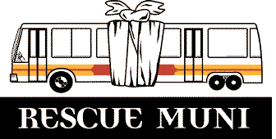
A Transit Riders Association
for San Francisco

P.O. Box 190966
San Francisco, CA 94119-0966

Voice mail: (415) 273-1558
E-mail: Transit1@rescuemuni.org
Website: http://www.rescuemuni.org

Mr Michael L. Burns
401 Van Ness Ave
Suite 334
San Francisco, CA 94102

Re: M & N-line Study Follow-up

The RESCUE Muni Metro Committee has studied the operation of the M-line and N-line and recommended changes for improvement in service and safety.

M - Ocean View
In December, 1999 we met with Muni personnel to discuss the October, 1999 M-line recommendations, and sent a letter in March, 2000 with the comments and the minutes of the December meeting. We have seen little progress and would like an updated status. Attached is a chart showing our observations, recommendations, meeting minutes, and the recent Metro committee’s follow-up questions and comments.

N - Judah
On November 9, 2000 we sent Muni our observations and recommendations for improved N-line service and safety. We received a reply from Lisa Mancini on November 30, 2000. Attached is a chart showing our observations, recommendations, Ms. Mancini’s response, and the recent Metro committee’s follow-up questions and comments.

We would like to schedule a meeting with appropriate staff to discuss our follow-up questions and comments. We would also like to schedule another on-site meeting to discuss M-line items #8-19. Please contact Howard Strassner at 661-8786, email ruthow@juno.com, address: 419 Vicente, SF 94116.

Regards,

Howard Strassner, RESCUE Muni Metro Committee Chair

cc: MTA CAC

